

VIC Minutes Table Derivation Manual

Principles and derivation of initial tables from physical interconnect billing data
______________________________
Contents
Contents 2
History 3
1. Background / Principles for the VIC Minutes Table 4
1.1 Context 4
1.2 VIC Objectives 4
1.3 Rationale for a Minutes Table 4
1.4 Application of a Minutes Table 5
1.5 Some CPs get more minutes than others from an E1 6
1.6 Each CP’s minutes tables are derived from their traffic profile – i.e. Average Minutes per day per busy hour erlang multiplied by the route capacity in erlangs. 6
1.7 Regulatory & Commercial Criteria for a Minutes Table: 7
1.8 Common Process 7
2. Description of Minutes Table Derivation Model 8
2.1 Issued Model 8
2.2 Summary of Derivation Process 9
2.3 Sample Data Extraction and Summarisation 9
2.4 Derivation Model Flowchart 10
2.5 DLE Minutes Derivation 11
2.6 Tandem Minutes Table Derivation 11
2.7 High Usage Minutes Table Derivation 12
2.8 Pivot Analysis 13
2.9 Data Extract Worksheet 14
2.10 Rationale for excluding routes with less than 7 Erlangs: 15
Appendix A: Details of data summarisation process 17

History
Issue | Date | Reason for Change
Issue 1.0 | 26th May 2006 | Initial Issue
Issue 2.0 | 17th July 2006 | - Addition of document history.  - Document title change following industry consultation  - Reformatted

- Background / Principles for the VIC Minutes Table
  - Context
- Ofcom/NCC - Technology Neutral Charging.
- BT intends to move to 21CN – consequential DLE Closure
- Maintaining LES Rate - BT solution is Virtual Interconnect Circuits to simulate DLE interconnect

  - VIC Objectives
- Enable LES rate via NGS
- Retain current competitive relativities between CPs.
- Offer no material advantage / disadvantage to CPs or BT.
- Enable new access to LES rate subject to the same conditions as before
- Protect existing CP investments
- Ensure CPs pay same amount for circuits and distance to carry the same minutes
- Ensure CPs continue to pay for local-tandem conveyance when insufficient local capacity procured.

  - Rationale for a Minutes Table
- Technically impossible to route BT originating calls to separate physical routes for each former DLE. So …
- “Both way” & Ingress traffic from different DLEs will be mixed on a single route. With the consolidated NGS route option tandem traffic is also mixed on the same physical route as DLE traffic. (please refer to schedule 131 for definition of the routing options).
- Individual DLE’s traffic can’t be constrained by peak minutes when it is combined on a single route.
- So we need to ensure the total minutes per DLE at LES rate do not exceed the capacity of the number of E1 interconnect circuits to each individual DLE and that the local-tandem NCC charge is paid for any additional minutes.
  - Application of a Minutes Table
- VIC route defined by Target DLE, NGS, (and Route ID if segregated route option - please refer to Schedule 131 for definition of the routing options).
- May optionally apply to specific direction / traffic types (e.g. CPS, NTS High Usage routes for BT terminating geographic calls.) N.b. The consolidated routing option permits only one traffic type/ definition per DLE. If VIC routes for separate traffic streams are required then the segregated routing option should be selected.
- Separate calculations for day / evening / weekend
- Minutes Table applies to all minutes assigned to the VIC route
- BT billed LES minutes as per standard conveyance bill
- CP billed NTS minutes - where CP bills NTS rate minus LES
- Minutes are based on routing plan not actual exit POC (for BT originated calls)
- Number of VIC E1s purchased taken from Circuit billing
- Minutes allowance looked up from minutes table and pro-rated to number of weekdays / weekend days per month
- Incremental rate is constant so it doesn’t matter which minutes are considered as overflowing
E.g. for daytime:
Total minutes = 120,000
Allowance = 106,029
Excess = 13,971
Rate = 0.1071 (from 1/4/2006)
Excess charge = £14.96 (ex VAT)
  - Some CPs get more minutes than others from an E1
Currently, minutes are constrained by peak capacity with physical circuits
- Flat traffic gives high minutes per busy hour erlang

- Peaky traffic give low minutes per busy hour erlang

  - Each CP’s minutes tables are derived from their traffic profile – i.e. Average Minutes per day per busy hour erlang multiplied by the route capacity in erlangs.
Minutes per erlang per day reflects CP specific traffic profile
Route size (E1 Capacity) scaled to TC4 reflects the relative efficiencies of larger routes

  - Regulatory & Commercial Criteria for a Minutes Table:
- Non discriminatory methodology
- Must accommodate route variability
- TEST 1: Must show same number of E1 circuits required for same minutes overall
I.e. The requirement for the number of VICs must be less than or equal to the number of circuits required on the basis of 102% of TC4 dimensioning for a given set of minutes.
- TEST 2: Extra E1s required is less than or equal to the number of reductions
I.e. Some routes may require augmenting but the quantity augmented must be less than or equal to the number reduced on other routes as a result of migration to VIC.
- Tests applied to CPs whole interconnect estate (for example see section 2.5)

  - Common Process
1. Select sample routes
- Exclude low usage routes with unrepresentative profile
2. Perform Common Calculation
- Average Day/Evening/Weekend profiles for each CP
- Uplift by a percentage of the Standard Deviation to allow for variability between routes
3. Calculate VICs required for each route
4. Apply Tests
5. Tune uplift percentage to achieve neutral impact on number of E1 Circuits required.
- Description of Minutes Table Derivation Model
  - Issued Model
- Specific to each CP traffic profile
- Separate tables for DLE and Tandem VICs both scaled by TC4
- Additional Table for High Usage BT terminating routes which do not have to be fully provided. Not scaled by TC4
- Peakiness of traffic profile reflected in values for “Average Minutes per day per busy hour Erlang”.
- Average minutes per day per busy hour erlang is the uplifted value derived as described in sections 2.4 / 2.5 / 2.6 below.

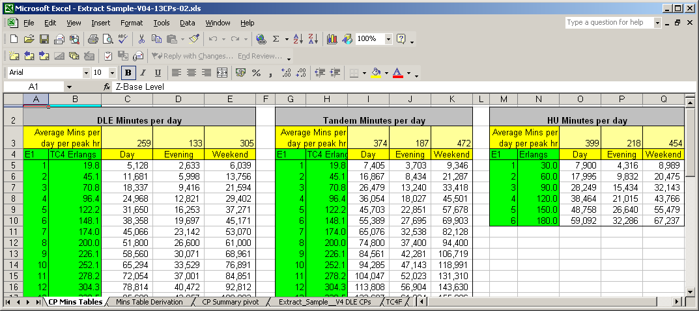

  - Summary of Derivation Process
1. Call records are examined for week commencing 6th March 2006
2. Call minutes are assigned to 15 minute slots. Long calls spanning more than one slot are split between the relevant slots.
3. For each Route / EBC time band, find the average minutes per busy hour erlang:
A. Non Overflow Minutes per 15 minute time slot are capped at 450 minutes per E1 of capacity (the maximum number of minutes achievable)
B. Busy hour minutes are calculated by finding the maximum total of four consecutive time slots within each EBC time band. Busy hour erlangs are then estimated by dividing the busy hour minutes by 60. This gives the lowest possible busy hr erlang value.
C: Average minutes per day per busy hour erlang for each EBC time period (e.g. Daytime) is calculated by dividing the sum of the non-overflow minutes by the number of days and by the TC4 erlang value if
- the busy hour erlang value for the sample period is greater than the TC4 erlang value applicable to the route capacity, AND
- the route still conforms to the fully provide obligation,
D. Otherwise the average minutes per day per busy hour erlang for each EBC time period is the sum of the non-overflow minutes by the actual average busy hour erlangs for the period. This is calculated by dividing the total non overflow minutes by the sum of the busy hour minutes and multiplying by 60.
4. The ratio of average minutes per day to average busy hour erlang for each route is summarised in the pivot table for each category of CP route (DLE, High Usage, Tandem). The pivot table shows the average minutes per day per busy hour erlang across all routes and the variances against the average.
5. The average of all routes is uplifted where necessary by a percentage of the variance to calculate the Minutes Table allowance.
6. The uplift is set at the level necessary to satisfy the commercial neutrality tests.
7. To find the minutes table allowance for a route with a given number of E1s multiply the capacity in Erlangs from TC4 table by the Minutes Table allowance from step 5 above to work out the allowance.

  - Sample Data Extraction and Summarisation
- Call Minutes taken from call records (CDRs) for week 6-12 March 2006.
- Circuit data taken from BT’s Geneva billing system at the beginning and end of March and related to logical routes (defined by POC 1141 code and CP switch 1141 code).
- CP originating CDRs related to logical routes using the CP point code / 1141 code from the CDR
- BT originating CDRs related to logical routes using the CP point code / 1141 code from the routing plan stored in RPD.
- Call minutes are assigned to 15 minute slots. Long calls spanning more than one slot are split between the relevant slots.
- For each Route:
A. Non overflow minutes per 15 minute time slot are capped at 450 minutes per E1 of capacity (the maximum number of minutes achievable)
B. Busy hour minutes are calculated by finding the maximum total of four consecutive time slots within each EBC time band.
- Routes excluded if the number of circuits changed through the month or if the number of channels or minutes was zero. This is to ensure stable data.
- Prior to importing into the Excel workbook: the data was summarised in three stages (For details see Appendix A)
A. 15 Minute route data –individual time slots
B. Daily Route Data – totals per day / EBC time band
C. Sample Period Route data – one record per logical route
- The Sample Period route Data is supplied to CPs for verification.

  - Derivation Model Flowchart
. | see 2.3 above
see. 2.1 above
see 2.5/2.6/2.7 below
see 2.8 below
see 2.9 below

  - DLE Minutes Derivation
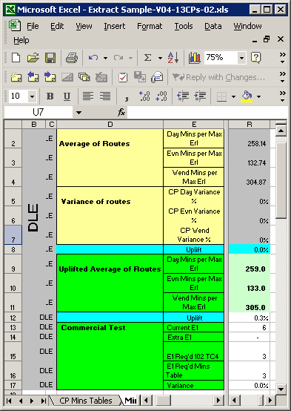 | - Qualifying routes are those which met the obligation to fully provide.  - Routes with less than 7 erlangs in the busy hour are excluded.  - CP Average minutes across all routes is calculated based on values extracted from the CP summary pivot worksheet.  - Standard Deviations calculated to reflect minutes variance between the CP’s routes.  - Average minutes then uplifted by the percentage of the minutes variance necessary to ensure commercial test passed. i.e. neutral impact on number of circuits required, See 1.7 above.  - Existing circuit requirement based on busy hr fitting within 102% TC4  - VIC circuit requirement based on minutes allowance = the uplifted average.  - Commercial tests in section 1.7 are passed if VIC requirement less than or equal to 102% TC4 requirement. Some routes may require augmenting offset by others which can be reduced.  - Generally CPs retain headroom above the TC4 level.
Commercial test demonstrated here

E.g. in order to avoid significant overflow a CP could plan on a minimum of 3 E1 based on 102% of TC4. The number of E1s required to avoid significant overflow is also 3E1s so the commercial test is passed. The example CP actually has 6 E1s at present so there is sufficient headroom to make overflow very unlikely.
  - Tandem Minutes Table Derivation
Same methodology applies as for DLE routes except routes to tandem switches selected.
  - High Usage Minutes Table Derivation
The same methodology applies as for DLE routes however a different commercial test is used.
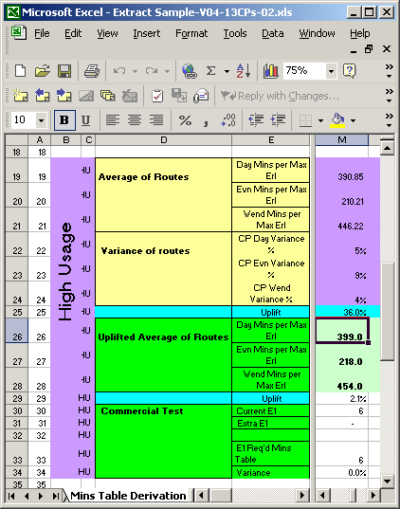 | - Qualifying routes are those where all the following apply:  - DLE routes.  - Under provided  - BT terminating traffic only  - 6E1 or less  - Commercial test checks the number of VIC E1 circuits required compared with current.  - TC4 not applicable to routes intended to physically overflow.  - Commercial test passed if number of VICs required is less than or equal to the current number of circuits.

  - Pivot Analysis
The Pivot table calculates total and average values for each route category from the extracted data worksheet as shown in the example below. This summary is the source of the data used in the minutes table derivation worksheet described above.
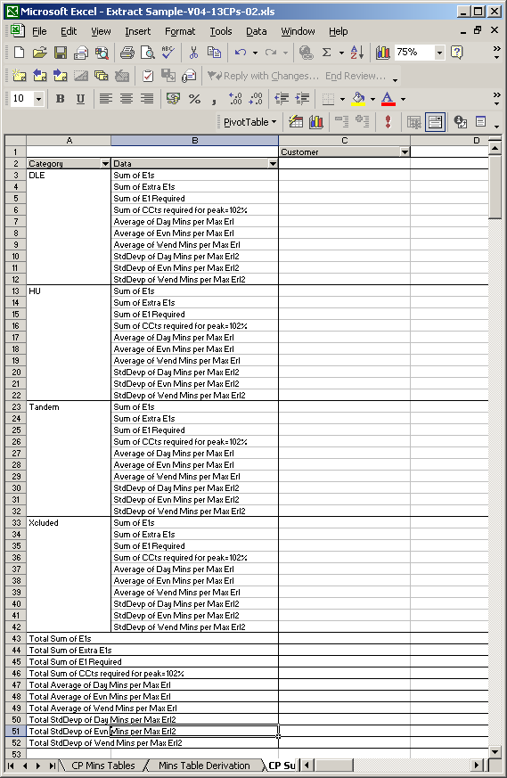
  - Data Extract Worksheet
- Network data summarising number of channels, minutes and busy hour erlangs for each route
- Divides Minutes by busy hour erlangs for Day/Evening/Weekend time bands to find average.
- Uses daily busy hour values to identify under provided routes
- Identifies low usage routes which may be unrepresentative of the CPs traffic flow.
- Uses traffic flow by direction to identify if route is ‘Egress only’.
- Classifies potential HU routes if under provided, Egress only, and 6 E1 or less.
- Categorises BT switch types
- Applies Minutes table values to minutes to calculate the number of VIC E1s required (the VIC requirement)
- Calculates E1s required if busy hr = 102% TC4 (the pre-VIC requirement)
- Identifies if VIC would require route to be augmented (Extra E1s Required). It also indicates where routes require fewer circuits with VIC.
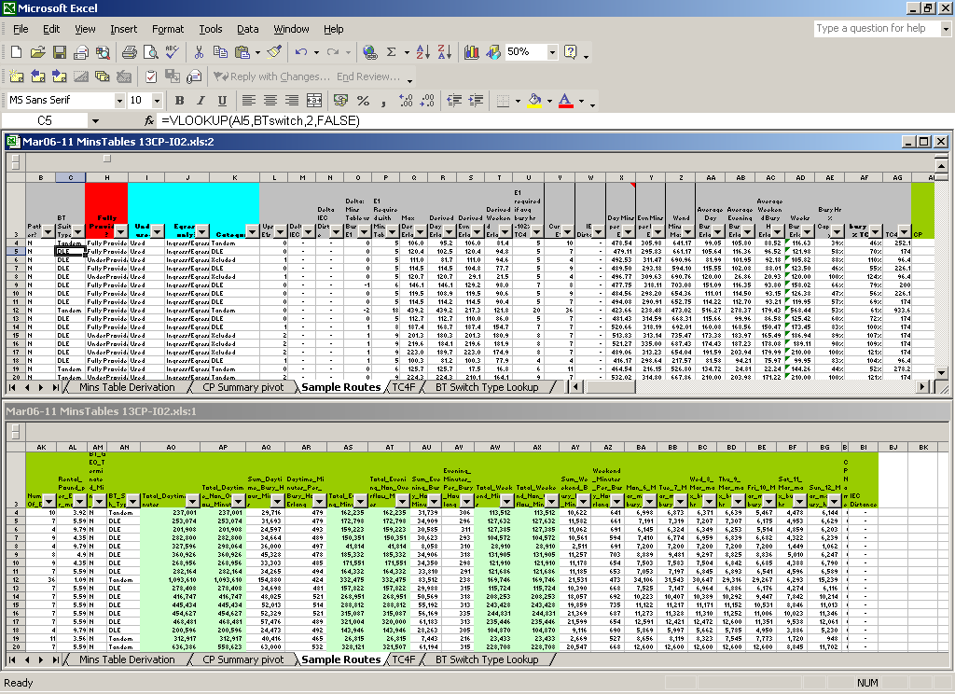
  - Rationale for excluding routes with less than 7 Erlangs:
Low traffic volumes do not have a representative traffic profile. Previously the under usage threshold had been 35% of TC4 however when CPs have unused E1 circuits to provide headroom, the 35% rule resulted in routes with representative traffic profiles being excluded. 7 Erlangs is approximately 35% of the TC4 capacity of a single E1.

Appendix A: Details of data summarisation process
This process is intended to cover both the initial minutes’ table from billing data and subsequent reviews. The fields in italics however are not required until after the VIC product has gone live.
15 Minute Route / Call Data  Summarised by:  - Date  - Time Period (15 min slot)  - CP  - POC NNI  - POC 1141  - CP Point code  - CP 1141  - Physical Route ID (Ericsson & Marconi Formats)  - DLE NNI (required for VIC)  - DLE 1141(required for VIC)  - VIC Type (Not VIC, Tandem, DLE/HU) (required for VIC)  Data:  - BT Geo terminating Minutes in progress during time period  - Other minutes in progress during time period  - Total Mins in progress (Field 12+Field13)  - EBC Time Band (Day/Eve/WE)  - E1 Purchased Capacity at start of sample week/month)  - E1 Purchased Capacity at last day of sample week/month)  - Overflow Minutes (maximum of zero or [Total Mins] minus 30*15*max E1 purchased capacity)  N.B. For BT originated traffic CP 1141/Route will be as per RPD routing plan. Physical overflow will be estimated by reference to the purchased capacity and not based on actual call routing. |  | Daily Route /Call Data  Summarised by:  - Date  - CP  - POC 1141  - CP Switch 1141  - EBC Time Band (D/E/W)  - VIC Type (Not VIC, Tandem, DLE/HU) (required for VIC)  - DLE 1141 (Required for VIC)  - Consolidated/ Segregated CP  - Physical Route ID (Ericsson & Marconi Formats)  Data:  - BT Geo Terminating Mins  - Other Mins  - Total Mins  - Overflow Minutes  - Non overflow minutes (=Field12-Field13)  - E1 Purchased Capacity at start of sample week/month)  - E1 Purchased Capacity at last day of sample week/month)  - Busy Hour Minutes  Busy hr being:  Maximum Non overflow minutes (total minus overflow) of all rolling 60 minute periods within the time band within the day.  E.g. for a weekday there would be 40 fifteen- min time slots in the daytime period 08:00 to 18:00. The busy hr would be the maximum of the 36 roling hours: 8:00-9:00, 8:15-9:15 …..16:45-17:45, 17:00-18:00. |  | Sample Period Route Data  Selected if: Constant E1s for Month AND Minutes > 0  Summarised by:  - CP  - POC 1141  - Consolidated CP?  - VIC Type (Not VIC, Tandem, DLE/HU) (required for VIC)  - DLE 1141 (Required for VIC)  and if not VIC and not consolidated CP then by:  - CP Switch 1141  - Physical Route ID (Ericsson & Marconi Formats)Summary Data:  Data:  - Number of E1s  - Rental £ per E1 per month  - BT Geo terminated minutes only (Y/N) = Y if sum of Other Minutes = zero.  - BT Switch type = DLE if (VIC traffic=N and POC1141=DLE) or (VIC traffic= yes and DLE1141=DLE and (consoldated CP=Y or Physical route segment type = DLE)) else tandem  - Total Daytime Mins  - Total Daytime non overflow minutes  - Sum of Daytime busy hr minutes  - Daytime mins per busy hr erlang= Total Daytime non overflow Mins * 60 / Sum Daytime busy hr minutes)  - Total Evening Mins  - Total Evening non overflow mins  - Sum of Evening busy hr minutes  - Evening mins per busy hr erlang= Total Evening non overflow Mins * 60 / Sum Evening busy hr minutes)  - Total Weekend Mins  - Total Weekend non overflow Minutes  - Sum of Weekend busy hr minutes  - Weekend mins per busy hr erlang = Total Weekend non overflow Mins * 60 / Sum Weekend busy hr minutes)  - Up to 31 individual daily busy hrs mins = for weekdays the max of the daytime and evening busy hr (e.g. 7 fields if the sample period is 1 week)  - Maximum minutes from 4 consecutive daily busy hrs in sample period.

